Infrastructure as a Service
Source Amazon white papers
- Defining IaaS
- The delivery of services such as hardware, software, storage, networking, data center space, and various utility software elements on request. Both public and private versions of IaaS exist.
- In the public IaaS, the user needs a simple sign-up mechanism to acquire resources. When users no longer need the resources, they simply de-provision them.
- In a private IaaS, the IT organization or an integrator creates an infrastructure designed to provide resources on demand to internal users and sometimes partners.
- IaaS is the fundamental element used by other cloud models. Some customers bring their own tools and software to create applications.
- Rather than purchase servers, software, racks, and having to pay for the datacenter space for them, the service provider rents those resources.
- Additionally, the infrastructure can be dynamically scaled up or down, based on the application resource needs.
- Multiple tenants can be on the equipment at the same time.
- Resources are typically billed based on a utility computing basis, so providers charge by how many resources are consumed.

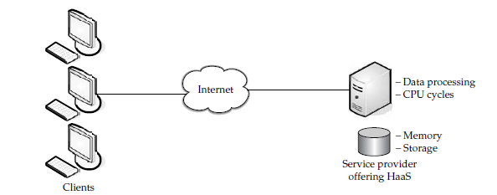

- Amazon and Cloud Computing

Amazon has a long history of using a decentralized IT infrastructure. This arrangement enabled our development teams to access compute and storage resources on demand, and it has increased overall productivity and agility. By 2005, Amazon had spent over a decade and millions of dollars building and managing the large-scale, reliable, and efficient IT infrastructure that powered one of the world’s largest online retail platforms. Amazon launched Amazon Web Services (AWS) so that other organizations could benefit from Amazon’s experience and investment in running a large-scale distributed, transactional IT infrastructure. AWS has been operating since 2006, and today serves hundreds of thousands of customers worldwide. Today Amazon.com runs a global web platform serving millions of customers and managing billions of dollars’ worth of commerce every year.
Using AWS, you can requisition compute power, storage, and other services in minutes and have the flexibility to choose the development platform or programming model that makes the most sense for the problems they’re trying to solve. You pay only for what you use, with no up-front expenses or long-term commitments, making AWS a cost-effective way to deliver applications.
Here are some of examples of how organizations, from research firms to large enterprises, use AWS today:
- A large enterprise quickly and economically deploys new internal applications, such as HR solutions, payroll applications, inventory management solutions, and online training to its distributed workforce.
- An e-commerce website accommodates sudden demand for a “hot” product caused by viral buzz from Facebook and Twitter without having to upgrade its infrastructure.
- A pharmaceutical research firm executes large-scale simulations using computing power provided by AWS.
- Media companies serve unlimited video, music, and other media to their worldwide customer base.

- The Differences that Distinguish AWS

AWS is readily distinguished from other vendors in the traditional IT computing landscape because it is:

Flexible
AWS enables organizations to use the programming models, operating systems, databases, and architectures with which they are already familiar. In addition, this flexibility helps organizations mix and match architectures in order to serve their diverse business needs.

Cost-effective
With AWS, organizations pay only for what they use, without up-front or long-term commitments.

Scalable and elastic
Organizations can quickly add and subtract AWS resources to their applications in order to meet customer demand and manage costs.

Secure
In order to provide end-to-end security and end-to-end privacy, AWS builds services in accordance with security best practices, provides the appropriate security features in those services, and documents how to use those features.

Experienced
When using AWS, organizations can leverage Amazon’s more than fifteen years of experience delivering large-scale, global infrastructure in a reliable, secure fashion.

- Amazon Web Services Cloud Platform

AWS is a comprehensive cloud services platform that offers compute power, storage, content delivery, and other functionality that organizations can use to deploy applications and services cost-effectively—with flexibility, scalability, and reliability. AWS self-service means that you can proactively address your internal plans and react to external demands when you choose.

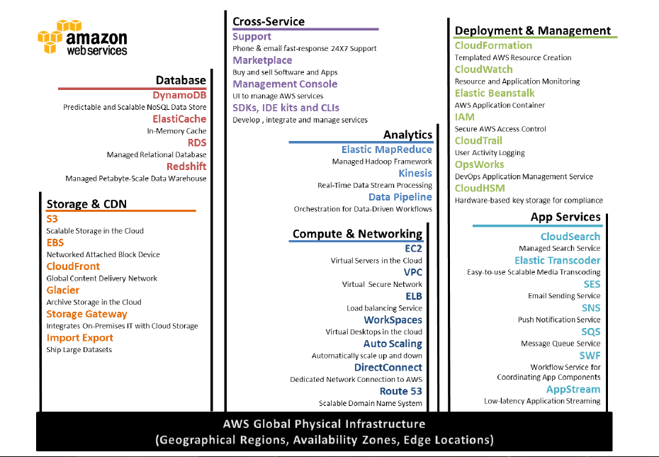

- Important AWS

5.1 ) Amazon Elastic Compute Cloud (Amazon EC2)
Amazon Elastic Compute Cloud (Amazon EC2) is a web service that provides resizable compute capacity in the cloud. It is designed to make web-scale computing easier for developers and system administrators.
Amazon EC2’s simple web service interface allows you to obtain and configure capacity with minimal friction. It provides you with complete control of your computing resources and lets you run on Amazon’s proven computing environment. Amazon EC2 reduces the time required to obtain and boot new server instances to minutes, allowing you to quickly scale capacity, both up and down, as your computing requirements change. Amazon EC2 changes the economics of computing by allowing you to pay only for capacity that you actually use. Amazon EC2 provides developers and system administrators the tools to build failure resilient applications and isolate themselves from common failure scenarios.

5.2) Auto Scaling
Auto Scaling allows you to scale your Amazon EC2 capacity up or down automatically according to conditions you define. With Auto Scaling, you can ensure that the number of Amazon EC2 instances you’re using increases seamlessly during demand spikes to maintain performance, and decreases automatically during demand lulls to minimize costs. Auto Scaling is particularly well suited for applications that experience hourly, daily, or weekly variability in usage. Auto Scaling is enabled by Amazon CloudWatch and available at no additional charge beyond Amazon CloudWatch fees.

5.3) Elastic Load Balancing
Elastic Load Balancing automatically distributes incoming application traffic across multiple Amazon EC2 instances. It enables you to achieve even greater fault tolerance in your applications, seamlessly providing the amount of load balancing capacity needed in response to incoming application traffic. Elastic Load Balancing detects unhealthy instances and automatically reroutes traffic to healthy instances until the unhealthy instances have been restored. Customers can enable Elastic Load Balancing within a single Availability Zone or across multiple zones for even more consistent application performance.

5.4) Amazon Virtual Private Cloud (Amazon VPC)
Amazon Virtual Private Cloud lets you provision a logically isolated section of the Amazon Web Services (AWS) Cloud where you can launch AWS resources in a virtual network that you define. You have complete control over your virtual networking environment, including selection of your own IP address range, creation of subnets, and configuration of route tables and network gateways.
You can easily customize the network configuration for your Amazon VPC. For example, you can create a public-facing subnet for your webservers that has access to the Internet, and place your backend systems such as databases or application servers in a private-facing subnet with no Internet access. You can leverage multiple layers of security (including security groups and network access control lists) to help control access to Amazon EC2 instances in each subnet.
Additionally, you can create a hardware virtual private network (VPN) connection between your corporate data center and your VPC and leverage the AWS cloud as an extension of your corporate data center.

5.5) Amazon Route 53
Amazon Route 53 is a highly available and scalable Domain Name System (DNS) web service. It is designed to give developers and businesses an extremely reliable and cost-effective way to route end users to Internet applications by translating human readable names, such as www.example.com, into the numeric IP addresses, such as 192.0.2.1, that computers use to connect to each other. Route 53 effectively connects user requests to infrastructure running in AWS, such as an EC2 instance, an elastic load balancer, or an Amazon S3 bucket. Route 53 can also be used to route users to infrastructure outside of AWS.

5.6) Amazon Simple Storage Service (Amazon S3)
Amazon S3 is storage for the Internet. It is designed to make web-scale computing easier for developers.
Amazon S3 provides a simple web services interface that can be used to store and retrieve any amount of data, at any time, from anywhere on the web. The container for objects stored in Amazon S3 is called an Amazon S3 bucket. Amazon S3 gives any developer access to the same highly scalable, reliable, secure, fast, inexpensive infrastructure that Amazon uses to run its own global network of websites. The service aims to maximize benefits of scale and to pass those benefits on to developers.

5.7) Amazon Glacier
Amazon Glacier is an extremely low-cost storage service that provides secure and durable storage for data archiving and backup. In order to keep costs low, Amazon Glacier is optimized for data that is infrequently accessed and for which retrieval times of several hours are suitable. With Amazon Glacier, customers can reliably store large or small amounts of data for as little as $0.01 per gigabyte per month, a significant savings compared to on-premises solutions.
Companies typically over-pay for data archiving. First, they're forced to make an expensive upfront payment for their archiving solution (which does not include the ongoing cost for operational expenses such as power, facilities, staffing, and maintenance). Second, since companies have to guess what their capacity requirements will be, they understandably over-provision to make sure they have enough capacity for data redundancy and unexpected growth. This set of circumstances results in under-utilized capacity and wasted money. With Amazon Glacier, you pay only for what you use. Amazon Glacier changes the game for data archiving and backup because you pay nothing up front, pay a very low price for storage, and can scale your usage up or down as needed, while AWS handles all of the operational heavy lifting required to do data retention well. It only takes a few clicks in the AWS Management Console to set up Amazon Glacier, and then you can upload any amount of data you choose.

5.8) Amazon Elastic Block Storage (EBS)
Amazon Elastic Block Store (EBS) provides block level storage volumes for use with Amazon EC2 instances. Amazon EBS volumes are network-attached, and persist independently from the life of an instance. Amazon EBS provides highly available, highly reliable, predictable storage volumes that can be attached to a running Amazon EC2 instance and exposed as a device within the instance. Amazon EBS is particularly suited for applications that require a database, file system, or access to raw block level storage.

5.9) AWS Import/Export
AWS Import/Export accelerates moving large amounts of data into and out of AWS using portable storage devices for transport. AWS transfers your data directly onto and off of storage devices using Amazon’s high-speed internal network and bypassing the Internet. For significant data sets, AWS Import/Export is often faster than Internet transfer and more cost effective than upgrading your connectivity.

5.10) Amazon CloudFront
Amazon CloudFront is a content delivery web service. It integrates with other Amazon Web Services to give developers and businesses an easy way to distribute content to end users with low latency, high data transfer speeds, and no commitments.
Amazon CloudFront can be used to deliver your entire website, including dynamic, static and streaming content using a global network of edge locations. Requests for objects are automatically routed to the nearest edge location, so content is delivered with the best possible performance. Amazon CloudFront is optimized to work with other Amazon Web Services, like Amazon S3 and Amazon EC2. Amazon CloudFront also works seamlessly with any origin server, which stores the original, definitive versions of your files. Like other Amazon Web Services, there are no contracts or monthly commitments for using Amazon CloudFront—you pay only for as much or as little content as you actually deliver through the service.

5.11) Amazon Relational Database Service (Amazon RDS)
Amazon Relational Database Service (Amazon RDS) is a web service that makes it easy to set up, operate, and scale a relational database in the cloud. It provides cost-efficient and resizable capacity while managing time-consuming database administration tasks, freeing you up to focus on your applications and business.
Amazon RDS gives you access to the capabilities of a familiar MySQL, Oracle, SQL Server or PostgreSQL database. This means that the code, applications, and tools you already use today with your existing databases can be used with Amazon RDS. Amazon RDS automatically patches the database software and backs up your database, storing the backups for a retention period that you define and enabling point-in-time recovery. You benefit from the flexibility of being able to scale the compute resources or storage capacity associated with your relational database instance by using a single API call. In addition, Amazon RDS makes it easy to use replication to enhance availability and reliability for production databases and to scale out beyond the capacity of a single database deployment for read-heavy database workloads.

5.12) Amazon DynamoDB
Amazon DynamoDB is a fast, fully managed NoSQL database service that makes it simple and cost-effective to store and retrieve any amount of data, and serve any level of request traffic. All data items are stored on Solid State Drives (SSDs), and are replicated across 3 Availability Zones for high availability and durability. With DynamoDB, you can offload the administrative burden of operating and scaling a highly available distributed database cluster, while paying a low price for only what you use
Amazon DynamoDB is designed to address the core problems of database management, performance, scalability, and reliability. Developers can create a database table that can store and retrieve any amount of data, and serve any level of request traffic. DynamoDB automatically spreads the data and traffic for the table over a sufficient number of servers to handle the request capacity specified by the customer and the amount of data stored, while maintaining consistent, fast performance. All data items are stored on solid state drives (SSDs) and are automatically replicated across multiple Availability Zones in a Region to provide built-in high availability and data durability.
Amazon DynamoDB enables customers to offload the administrative burden of operating and scaling a highly available, distributed database cluster while only paying a low variable price for the resources they consume.

5.13) Amazon ElastiCache
Amazon ElastiCache is a web service that makes it easy to deploy, operate, and scale an in-memory cache in the cloud. The service improves the performance of web applications by allowing you to retrieve information from a fast, managed, in-memory caching system, instead of relying entirely on slower disk-based databases. ElastiCache supports two open-source caching engines.
Memcached - a widely adopted memory object caching system. ElastiCache is protocol compliant with Memcached, so popular tools that you use today with existing Memcached environments will work seamlessly with the service.
Redis a popular open-source in-memory key-value store that supports data structures such as sorted sets and lists. ElastiCache supports Redis master / slave replication which can be used to achieve cross AZ redundancy.

5.14) Amazon Simple Queue Service (Amazon SQS)
Amazon Simple Queue Service (Amazon SQS) is a fast, reliable, scalable, fully managed message queuing service. SQS makes it simple and cost-effective to decouple the components of a cloud application. You can use SQS to transmit any volume of data, at any level of throughput, without losing messages or requiring other services to be always available. With SQS, you can offload the administrative burden of operating and scaling a highly available messaging cluster, while paying a low price for only what you use.

5.15) Amazon Simple Notification Service (Amazon SNS)
Amazon Simple Notification Service (Amazon SNS) Amazon Simple Notification Service (SNS) is a fast, flexible, fully managed push messaging service. SNS makes it simple and cost-effective to push to mobile devices such as iPhone, iPad, Android, Kindle Fire, and internet connected smart devices, as well as pushing to other distributed services.
Besides pushing cloud notifications directly to mobile devices, SNS can also deliver notifications by SMS text message or email, to Simple Queue Service (SQS) queues, or to any HTTP endpoint.
To prevent messages from being lost, all messages published to Amazon SNS are stored redundantly across multiple availability zones.

5.16) Amazon Simple Email Service (Amazon SES)
Amazon Simple Email Service (Amazon SES) is a highly scalable and cost-effective bulk and transactional email sending service for organizations and developers. Amazon SES eliminates the complexity and expense of building an in-house email solution or licensing, installing, and operating a third-party email service. The service integrates with other AWS services, making it easy to send emails from applications that are hosted on services such as Amazon EC2. With Amazon SES there is no long-term commitment, minimum spend, or negotiation required. Organizations can utilize a free usage tier and after that enjoy low fees for the number of emails sent plus data transfer fees.
Building large-scale email solutions to send marketing and transactional messages is often a complex and costly challenge for organizations. To optimize the percentage of emails that are successfully delivered, organizations must deal with email server management and network configuration, plus they must meet rigorous Internet service provider (ISP) standards for email content. Additionally, many third-party email solutions require contract and price negotiations, as well as significant up-front costs.
Amazon SES eliminates these challenges and enables organizations to benefit from the years of experience and sophisticated email infrastructure Amazon.com has built to serve its own large-scale customer base. Using SMTP or a simple API call, an organization can now access a high-quality, scalable email infrastructure to efficiently and inexpensively communicate to their customers. For high email deliverability, Amazon SES uses content filtering technologies to scan an organization’s outgoing email messages to help ensure that the content meets ISP standards. The email message is then either queued for sending or routed back to the sender for corrective action. To help organizations further improve the quality of email communications with their customers, Amazon SES provides a built-in feedback loop, which includes notifications of bounce backs, failed and successful delivery attempts, and spam complaints.

5.17) Amazon CloudSearch
Amazon CloudSearch is a fully-managed service in the AWS Cloud that makes it easy to set up, manage, and scale a search solution for your website or application. Amazon CloudSearch enables you to search large collections of data such as web pages, document files, forum posts, or product information.

5.18) Amazon CloudWatch
Amazon CloudWatch provides monitoring for AWS cloud resources and the applications customers run on AWS. Developers and system administrators can use it to collect and track metrics, gain insight, and react immediately to keep their applications and businesses running smoothly. Amazon CloudWatch monitors AWS resources such as Amazon EC2 and Amazon RDS DB Instances, and can also monitor custom metrics generated by a customer’s applications and services. With Amazon CloudWatch, you gain system-wide visibility into resource utilization, application performance, and operational health.
Amazon CloudWatch provides a reliable, scalable, and flexible monitoring solution that you can start using within minutes. You no longer need to set up, manage, or scale your own monitoring systems and infrastructure. Using Amazon CloudWatch, you can easily monitor as much or as little metric data as you need. Amazon CloudWatch lets you programmatically retrieve your monitoring data, view graphs, and set alarms to help you troubleshoot, spot trends, and take automated action based on the state of your cloud environment.

5.19) AWS Elastic Beanstalk
AWS Elastic Beanstalk is an easy-to-use service for deploying and scaling web applications and services developed with popular programming languages such as Java, .NET, PHP, Node.js, Python and Ruby. You simply upload your application and Elastic Beanstalk automatically handles the deployment details of capacity provisioning, load balancing, auto-scaling and application health monitoring. At the same time, with Elastic Beanstalk, you retain full control over the AWS resources powering your application and can access the underlying resources at any time.
Most existing application containers or platform-as-a-service solutions, while reducing the amount of programming required, significantly diminish developers' flexibility and control. Developers are forced to live with all the decisions pre-determined by the vendor - with little to no opportunity to take back control over various parts of their application's infrastructure. However, with Elastic Beanstalk, you retain full control over the AWS resources powering your application. If you decide you want to take over some (or all) of the elements of their infrastructure, you can do so seamlessly by using Elastic Beanstalk's management capabilities.

